**1 Dimensional Force model**

Questions

Whether or not different distributions of parameters in force model affect bottleneck’s occurrence? If yes, why does the bottle neck occur?

Simulation

Simulate two pedestrians x and y moving from opposite directions on 1-dimension based on two following social force models; only consider pedestrians x and y are flat without radius. Its simplification aims to find out the fundamental reason why pedestrians stop.

First model

$$v_{x}=\frac{dx}{dt}=α_{x}x-β_{x}e^{-d_{xy}}$$

$$v_{y}=\frac{dy}{dt}={-α}_{y}y+β_{y}e^{-d_{xy}}$$

Update position by Euler method:

x($t+Δt)=vΔt+x(t)$

For each above model, answer the following question

“DO THEY STOP (NEVER, FREQUENTLY, RARERLY, OR ALWAYS)?” by

Bottleneck frequency over 50 simulation times, simulation duration = 50 (each run random placement) ( $α_{y}=0.8)$ ( $β_{y}=2)$ (value of elder people)

In first model

|  |  |  |  |  |  |
| --- | --- | --- | --- | --- | --- |
|  | $$β_{x}= β_{y}$$ | $$β_{x}= {2β}_{y}$$ | $$β_{x}= {3β}_{y}$$ | $$β_{x}= {4β}_{y}$$ | $$β_{x}= {5β}_{y}$$ |
| $$α_{x} =α_{y}$$ | 100% | 100% | 100% | 100% | 100% |
| $$α_{x} =2α_{y}$$ | 62% | 88% | 92% | 94% | 92% |
| $$α_{x} ={3α}_{y}$$ | 24% | 28% | 30% | 42% | 42% |
| $$α_{x} ={4α}_{y}$$ | 8% | 20% | 16% | 22% | 20% |
| $$α_{x} =5α_{y}$$ | 0% | 14% | 10% | 16% | 10% |

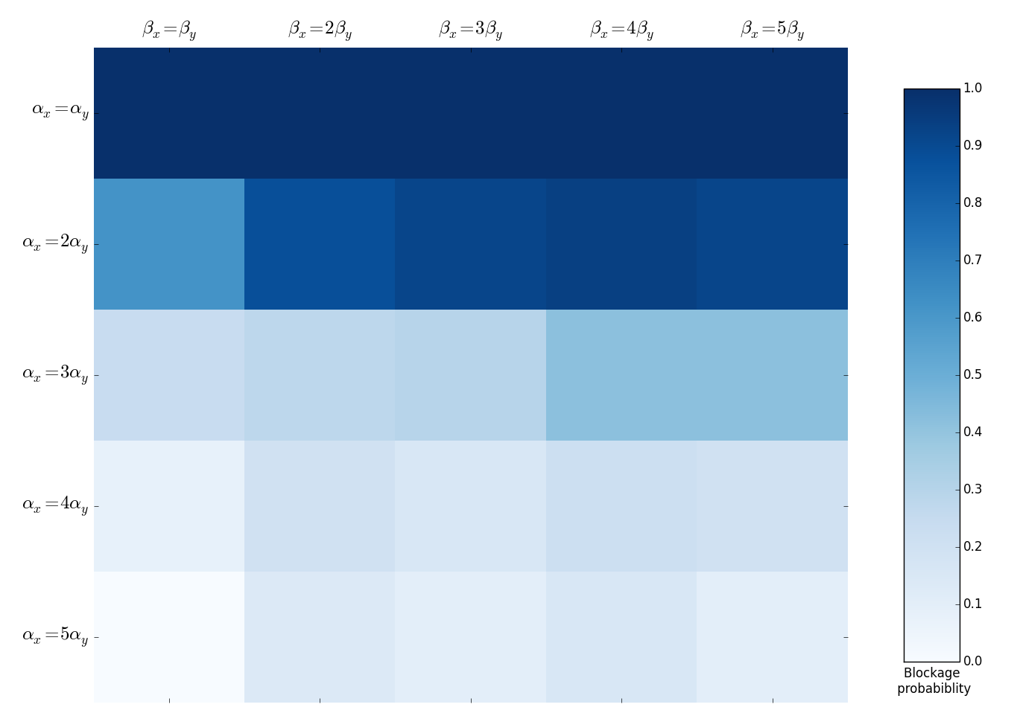

Why does the bottleneck happen?

In this model, bottleneck occurs when delta position is insignificant, it’s mean **integer of**

$$αx-βe^{-d_{xy}} ≅ 0 (1)$$

From (1), we found that, pedestrian y stops when

$$αx≅βe^{-d_{xy}} (2)$$

$$d_{xy}≅ln\left(β_{x}\right)-ln⁡(α_{x}|x|) (3)$$

$\left|ln\left(β_{x}\right)-\ln\left(α_{x}x\right)\right|$ at time *t* is stop condition of pedestrian x

This condition can be pre-known because x is pre-known. When $β_{y}$ increase, constrain value of ( $ln\left(β_{y}\right)-ln⁡(α_{y}y) )$ is wider if $α_{y}$ is small. Thus, people are easier to be stopped.

Looking at the diagonal, the more difference between two pedestrians, the fewer bottlenecks occur.

When B increase, more chances to get bottle neck because the increase rate of $β_{x}$ is higher than the increasing rate of $α_{x}$

When $α_{x}$ increases, $d_{xy} is going down,$ not easy to be stopped. Smaller $β_{x}$ we have, the fewer chances to have bottleneck.

Desire_velocity is constant, people couldn’t move backward.

Second model

$$\frac{dv_{x}}{dt}=α\left(v_{x}^{d}-v_{x}\right)-β_{x}e^{-d_{xy}}$$

$$\frac{dv_{y}}{dt}=α\left({-v}_{y}^{d}-v_{y}\right)+β_{y}e^{-d_{xy}}$$

Update position by Euler method:

$$p\left(t+Δt\right)= \frac{1}{2}a{Δt}^{2}+V\left(t\right)Δt+p(t)$$

V($t+Δt)=aΔt+V(t)$

Because we don’t allow people move backward, we set this rule

$$\left\{\begin{aligned}p\left(t+Δt\right)=p\left(t\right) if p\left(t+Δt\right) further than p\left(t\right)from target \\ V(t+Δt)=0\end{aligned}\right.$$

Experiment at ( $v_{y}^{d}=0.8)$ ( $β_{y}=2.0)$ and $α=1$

|  |  |  |  |  |  |
| --- | --- | --- | --- | --- | --- |
|  | $$β_{x}= β_{y}$$ | $$β_{x}= {2β}_{y}$$ | $$β_{x}= {3β}_{y}$$ | $$β_{x}= {4β}_{y}$$ | $$β_{x}= {5β}_{y}$$ |
| $$v_{x}^{d}{=v}_{y}^{d}$$ | 4% | 0% | 10% | 4% | 0% |
| $$v_{x}^{d}{=2v}_{y}^{d}$$ | 0% | 0% | 0% | 6% | 0% |
| $$v_{x}^{d}{=3v}_{y}^{d}$$ | 0% | 0% | 0% | 0% | 0% |
| $$v_{x}^{d}{=4v}_{y}^{d}$$ | 0% | 0% | 0% | 0% | 0% |
| $$v_{x}^{d}{=5v}_{y}^{d}$$ | 0% | 0% | 0% | 0% | 0% |

Experiment at $v_{y}^{d}=0.8,β_{x}=2.0$, and $α=1$

|  |  |  |  |  |  |
| --- | --- | --- | --- | --- | --- |
|  | $$β_{y}= β_{x}$$ | $$β_{y}= {2β}_{x}$$ | $$β_{y}= {3β}_{x}$$ | $$β_{y}= {4β}_{x}$$ | $$β_{y}= {5β}_{x}$$ |
| $$v_{x}^{d}{=v}_{y}^{d}$$ | 6% | 0% | 4% | 6% | 0% |
| $$v_{x}^{d}{=2v}_{y}^{d}$$ | 0% | 0% | 0% | 0% | 0% |
| $$v_{x}^{d}{=3v}_{y}^{d}$$ | 0% | 0% | 0% | 0% | 0% |
| $$v_{x}^{d}{=4v}_{y}^{d}$$ | 0% | 0% | 0% | 0% | 0% |
| $$v_{x}^{d}{=5v}_{y}^{d}$$ | 0% | 0% | 0% | 0% | 0% |

Why does the bottleneck happen?

In this model, a person stops when

$$α\left(v_{x}^{d}-v_{x}\right)-β_{x}e^{-d_{xy}} ≅ 0 (1)$$

$$α\left(v_{x}^{d}-v_{x}\right)≅βe^{-d_{xy}} (2)$$

$\left|d_{xy}\right|≅ln\left(β_{x}\right)-ln⁡\left(α\left(v_{x}^{d}-v_{x}\right)\right)$ (3)

$\left|d_{xy}\right|≅ln\left(β_{x}\right)-\ln\left(α\right)-ln⁡\left(v_{x}^{d}-v_{x}\right)$ (4)

Comeback, the two prototype, it’s is easier to be bottleneck because the ratio of $v_{x}^{d}{=5v}_{y}^{d} while β_{y}= {5β}_{x}$, it’s means in average prototype, std is wide, people can have higher desired velocity but lower interaction strength.

Bottle neck when two pedestrians satisfy

$$\left\{\begin{aligned}\left|d_{xy}\right|≅ln\left(β_{x}\right)-\ln\left(α\right)-ln⁡\left(v_{x}^{d}-v_{x}\right) \\ \left|d_{xy}\right|≅ln\left(β_{y}\right)-\ln\left(α\right)-ln⁡\left(v_{y}^{d}-v_{y}\right) \end{aligned}\right.$$

$$ln\left(β_{x}\right)-\ln\left(α\right)-\ln\left(v_{x}^{d}-v_{x}\right)= ln\left(β_{y}\right)-\ln\left(α\right)-ln⁡\left(v_{y}^{d}-v_{y}\right)$$

$ln\left(β_{x}\right)-\ln\left(v_{x}^{d}-v_{x}\right)=$ $ln\left(β_{y}\right)-ln⁡\left(v_{y}^{d}-v_{y}\right)$

$ln\left(β_{x}\right)-ln\left(β_{y}\right)=$ $\ln\left(v_{x}^{d}-v_{x}\right)-ln⁡\left(v_{y}^{d}-v_{y}\right)$